**\Create XCAT Statefull image**

You can find statefull image by just typing command **lsdef –t osimage** where you will see three images.

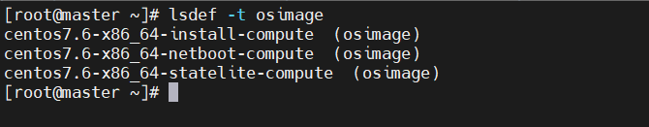you can use “centos7.6-x86_64-install-compute” for statefull installation.

To check contains of image run following command:

**#lsdef -t osimage centos7.6-x86_64-install-compute**

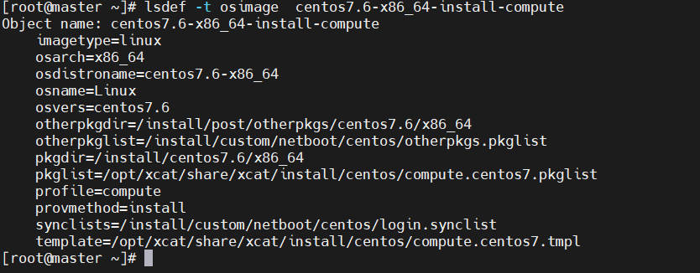

To add additional rpms that you also want installed, make a directory to hold them, create a list of the rpms you want installed, and add that information to the osimage definition:

* **Create Other package directory**

Create a directory to hold the additional rpms:

**# mkdir -p /install/post/otherpkgs/centos7.6/x86_64**

**#cd /install/post/otherpkgs/centos7.6/x86_64**

Copy rpms into /install/post/otherpkgs/centos7.6/x86_64 and create repo.

#**createrepo .**

* **Create Otherpackage file**

Create a file that lists the additional rpms that should be installed. For example, in

# mkdir /install/custom/netboot/centos/

**# vim /install/custom/netboot/centos/otherpkgs.pkglist**

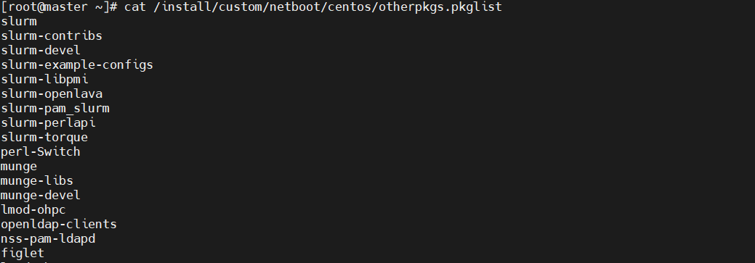

**List of packages:**

Slurm,slurm-contribs,slurm-devel,slurm-example-configs,slurm-libpmi,slurm-openlava,slurm-pam_slurm,slurm-perlapi,slurm-torque,perl-Switch,munge,munge-libs,munge-devel,lmod-ohpc,openldap-clients,nss-pam-ldapd, figlet,lmodohpc,prelink,aide,iftop,fail2ban,rkhunter,mod_ssl,beegfs-common,beegfs-helperd,beegfs-utils,beegfs-client

Add both the directory and the file to the osimage definition:

**# Chdef –t osimage centos7.9-x86_64-install-compute otherpkgdir=/install/post/otherpkgs/centos7.9/x86_64 otherpkglist=/install/custom/netboot/centos/otherpkgs.pkglist**

* **Create Partition File**

Vim /install/custom/partitionfile :

clearpart --all --initlabel --drives=sda,sdb

volgroup data_vg --pesize=4096 pv.1005

volgroup os_vg --pesize=4096 pv.452

part pv.1005 --fstype="lvmpv" --ondisk=sdb --size=5720638

part /boot/efi --fstype="efi" --ondisk=sda --size=1024 --fsoptions="umask=0077,shortname=winnt"

part /boot --fstype="xfs" --ondisk=sda --size=10240

part pv.452 --fstype="lvmpv" --ondisk=sda --size=1132862

logvol /var --fstype="xfs" --size=614400 --name=var --vgname=data_vg

logvol /opt --fstype="xfs" --size=204800 --name=opt --vgname=data_vg

logvol /var/log/audit --fstype="xfs" --size=512000 --name=var_log_audit --vgname=data_vg

logvol swap --fstype="swap" --size=49152 --name=swap --vgname=os_vg

logvol / --fstype="xfs" --size=1083707 --name=root --vgname=os_vg

logvol /var/log --fstype="xfs" --size=4184631 --name=var_log --vgname=data_vg

logvol /tmp --fstype="xfs" --size=204800 --name=tmp --vgname=data_vg

You can set the partitionfile path using the following command:

**# chdef -t osimage -o centos7.9-x86_64-install-compute partitionfile=/install/custom/partitionfile**

* **Create Synclist File**

In the installation process, xCAT needs to figure out the location of the synclist file automatically, so the synclist should be put into the specified place with the proper name.

You can set the synclist path using the following command:

**# chdef -t osimage -o centos7.9-x86_64-install-compute synclists=/install/custom/netboot/centos/login.synclist**

**Edit template file**

**Vim /opt/xcat/share/xcat/install/centos/compute.centos7.tmpl**

Search for the skipx parameter and comment it

Search for the text and comment it

Add your password:

auth --enableshadow --passlog=sha512rootpw --iscrypted $1$/JUDobnI$NgEGjG.wOlOIo75nWoJ5o/

* **Postscripts**

Add following lines at the end of this file

# vim /install/postscripts/remoteshell:

#!/bin/bash

wget http://172.10.0.1:80/install/post/otherpkgs/centos7.9/x86_64/pam_captcha.so -P /usr/lib64/security/

sed -i "/#%PAM-1.0/a\\auth required pam_captcha.so randomstring" /etc/pam.d/sshd

sed -i 's/^ChallengeResponseAuthentication.*/ChallengeResponseAuthentication yes/g' /etc/ssh/sshd_config

service sshd restart

systemctl set-default graphical.target

export SLURMUSER=900

groupadd -g $SLURMUSER slurm

useradd -m -c "SLURM workload manager" -d /var/lib/slurm -u $SLURMUSER -g slurm -s /bin/bash slurm

mkdir /var/log/munge/

touch /var/log/munge/munged.log

chown -R munge:munge /var/log/munge

chown -R munge:munge /run/munge

chown -R munge: /etc/munge

chown -R munge:munge /etc/munge/ /var/log/munge/ /var/lib/munge/ /run/munge

chmod 0700 /etc/munge/ /var/log/munge/ /var/lib/munge/ /run/munge/

chmod 0700 /etc/munge/ /var/log/munge/ /var/lib/munge/ /run/munge/

chmod 755 /run/munge

*note : copy pam_captcha.so file to this path /install/post/otherpkgs/centos7.9/x86_64/

* **Setup of mellanox in stateful image**

For mellanox installation copy mellanox iso to the following path

/install/custom/**MLNX_OFED_LINUX-5.5-1.0.3.2-rhel7.9-x86_64.iso**

* **Setup Postbootscripts**

vim /install/postscripts/otherpkgs

add following lines in the starting

**#enable debug**

**#set –x**

**mkdir /etc/yum.repos.d/yum.bk**

**mv /etc/yum.repos.d/CentOS-* /etc/yum.repos.d/yum.bk**

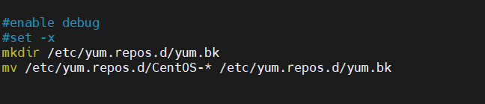

add following lines at the ending

**mv /etc/yum.repos.d/yum.bk/* /etc/yum.repos.d/**

**rm -rf /etc/yum.repos.d/yum.bk**

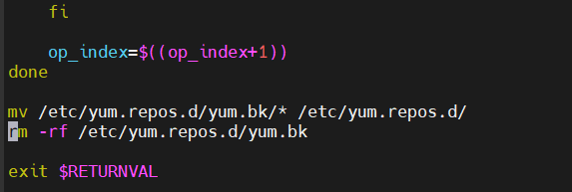

* **Create node definition**

**# mkdef -t node cn00 groups=compute,all ip=192.168.20.12 mac=00:0c:29:c4:50:25 netboot=xnba**

**# chdef cn00 postscripts=syslog,remoteshell,syncfiles,mlnxofed_ib_install -p “/install/custom/MLNX_OFED_LINUX-5.4-3.1.0.0-rhel7.9-x86_64.iso”,”confignetwork –s”,ssh_captcha**

**#chdef cn00 postbootscripts=otherpkgs**